Michael Grinnell Portfolio Design Document

# Project Overview

## Objective

The primary objective of michaelgrinnell.com and dj.michaelgrinnell.com is to establish a professional online presence that showcases Michael Grinnell's diverse skills in software development and DJing and also highlights his specialization and passion for audio programming. These platforms are designed to attract potential clients and employers in the fields of audio software development, gaming audio programming, and related industries.

## Target Audience

Software Development Professionals: Specifically, those in the audio and music technology sector, including companies involved in VST plugin development, game development studios, and independent artists or producers seeking custom audio solutions.

Music and Entertainment Industry Professionals: Including event organizers, music producers, and artists who might benefit from Michael's DJ services and his expertise in sound design and audio programming.

## Unique Value Proposition

Michael Grinnell uniquely combines his programming prowess with a deep understanding of sound design and audio technology. This dual expertise enables him to offer specialized services in creating advanced audio software solutions (like VST plugins) and interactive audio for games, alongside providing professional DJ services. This combination of skills sets him apart in the tech and music industries, offering a comprehensive package of programming and sound design. The website will show that I am good a design, while also showing that I have the technical capabilities to implement.

# Website Strategy:

The website will implement modern design principles with a minimalist aesthetic that focus on user experience. Responsiveness and intuitive navigation are central elements, ensuring accessibility and seamless interaction across all devices.

## Development Strategy

### Responsive Layout:

* Bootstrap and react for responsiveness and dynamic content rendering.
* Multi-device testing to ensure functionality across devices and screen sizes.

### Performance

* File minification, caching, and asynchronous loading to streamline performance.
* Regular assessments with tools like Google Lighthouse.

### SEO

* Optimized URLs and internal linking for better indexing.
* Google Analytics integration for insights into user interactions.
* Adherence to accessibility best practices, including multilingual support.

## Design Strategy:

* Minimalistic Style
* Implementation of a light and dark theme.
* Typography chosen for readability with distinct fonts for main text and headings.
* Generous whitespace for a clean layout and to emphasize content.
* Uniform margins and padding to maintain a structured appearance.

## Content Strategy:

* WordPress as the headless CMS for scalable content management.
* Image and asset optimization for reduced load times.
* Strategic use of relevant keywords for improved search rankings.
* Headers, titles, descriptions, and images tailored for SEO.
* Implementing an accessible design with ARIA roles, alt text, and contrast checks.
* Providing content translation for a global audience with diverse language needs.

# Additional Objectives

## Home Server for Hosting:

* Configure home server for web hosting.

## Secondary Site for DJ Services (dj.michaelgrinnell.com):

* Utilize the same backend and styling for brand consistency.
* Ensure both sites are interlinked for seamless navigation.
* The DJ site should focus on your music, gigs, mixes, and production work.

# Additional Features

## Animations

* Implement a particles animation, ensure that doesn’t distract from the content.
* Slide in animations on content

## Theme

* Detect user’s system preferences for initial theme setting.
* Implement a switch to set dark or light mode
* Implement a feature to select the text size

## Filtering Mechanism for Projects and Blog Posts

* Implement filters to allow users to search by tag, category, date, etc.
* Ensure the filtering UI is intuitive and integrates well with the overall design of the site.

## Dynamic Navigation

* If user on homepage, scroll to section, otherwise navigate to relevant page.
* Contact form opens in a model

## Cross-Linking Between Sites

* Make sure the link to your DJ site is prominent on your main site and vice versa.
* Use this as an opportunity to showcase the diversity of your skills and interests.

# Style Guide

## Light Theme:

* Primary Colours**:**
* Secondary Colours**:**
* Background Colour**:**

## Dark Theme:

* Primary Colours:
* Secondary Colours:
* Background Colour:

## Typography:

* Main Font Selection: 'Roboto', sans-serif
* Headings Font Style: 'Montserrat', sans-serif
* Font Sizing: Body text: 16px. Headings: Ranging from 22px for H1 to 14px for H6

# UI Elements

## Main Navbar

The main nav bar should have links centred, with the logo aligned left and buttons for setting the theme and font size aligned to the right. It should use icons for the links.



## Contact Dialogue

This will be a model/dialogue element that can be re-used throughout the site to avoid creating multiple contact forms. Ensure to include icon links to relevant places such as LinkedIn or Github other professional social media profiles.

<https://www.youtube.com/watch?v=ywtkJkxJsdg&t=3s&ab_channel=WebDevSimplified>

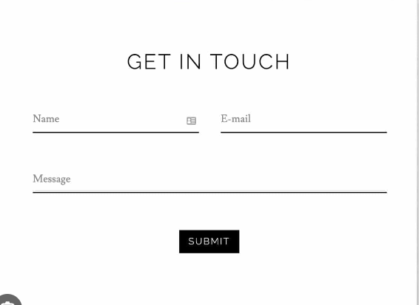

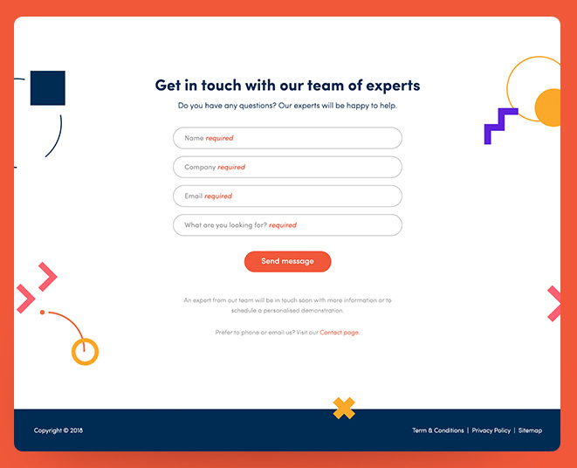

## **Tags Search**

Search feature to implement for projects and blogs  
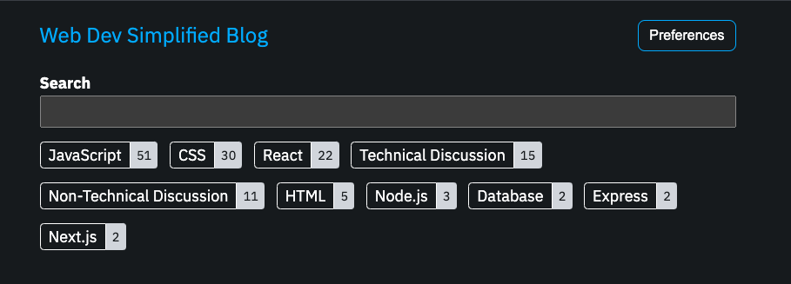

## **Footer**:

The footer should include contact information, copywrite, legal disclaimers, and offer quick links to other sections of your portfolio or external profiles. Built with React, bootstrap and WordPress



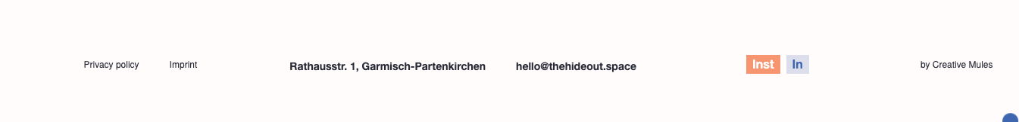

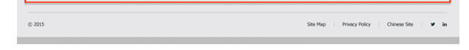

# Main domain michaelgrinnell.com

## Home Page

For the home page the goal is to immediately capture the visitor's attention and guide them to key information about my skills and work.

### Hero Section:

1. Headline: A clear, compelling statement about who you are (e.g., "Innovative Software Engineer Specializing in Game and Audio Programming").
2. Subhead line: A brief sentence or two that expands on your headline, adding context or specifics about your expertise.
3. Call to Action (CTA): A button or link inviting visitors to learn more about you, view your projects, or contact you.

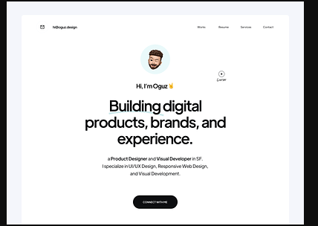



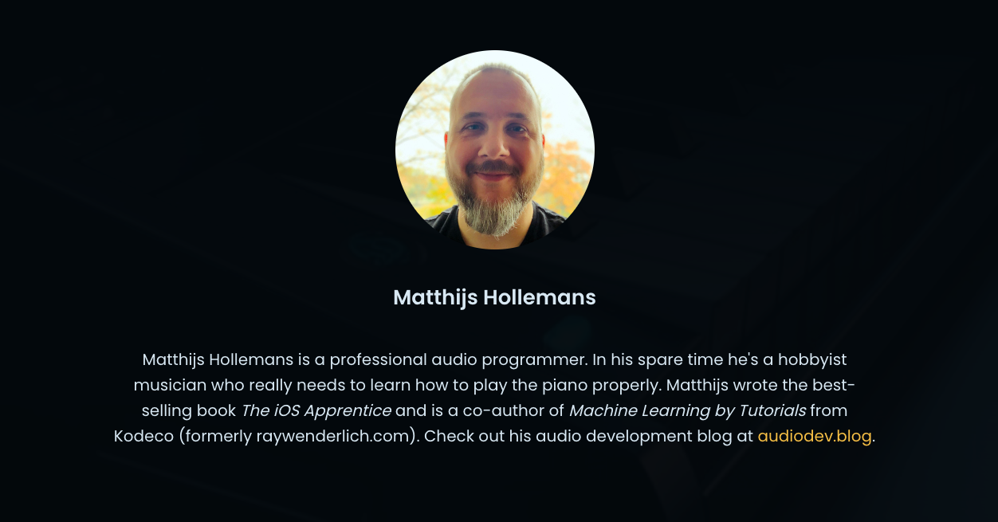

### About Me:

A concise introduction that includes, professional title, areas of specialization, and a summary of my background and what drives you as a software engineer. This section should set the stage for the rest of the content. Add in a button that opens a contact form model.

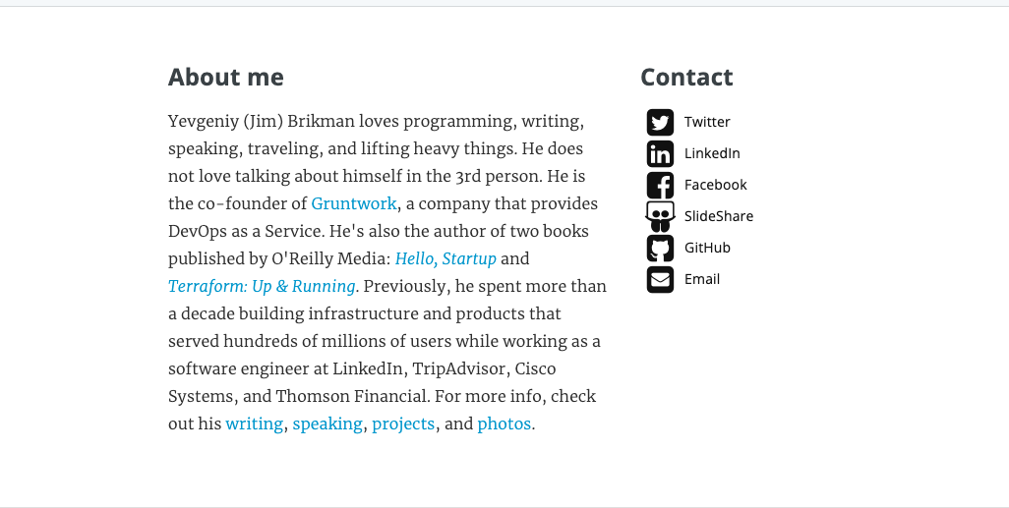

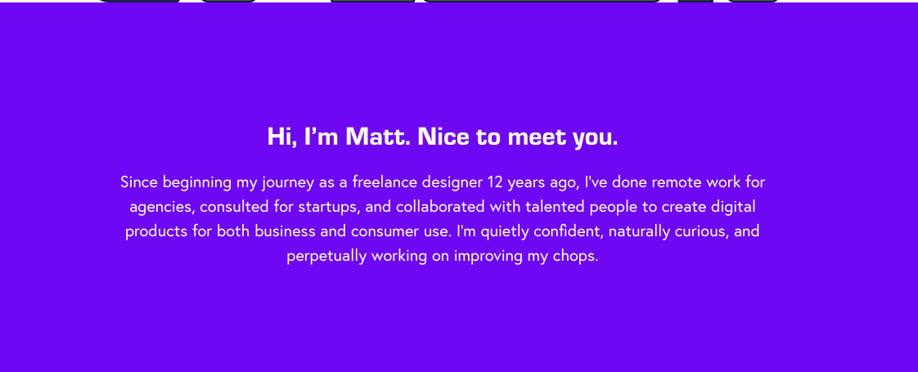

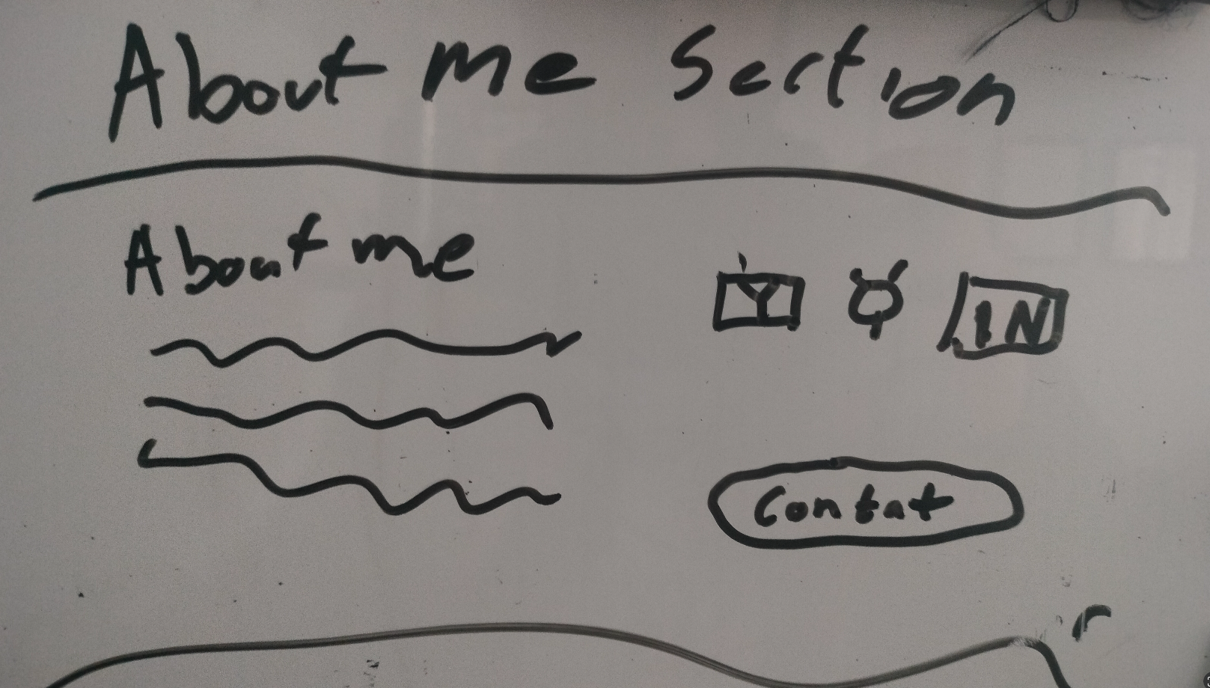

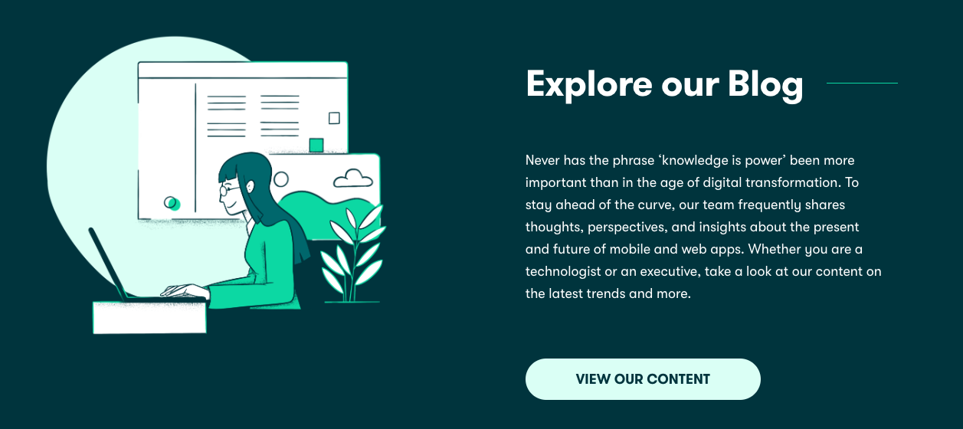

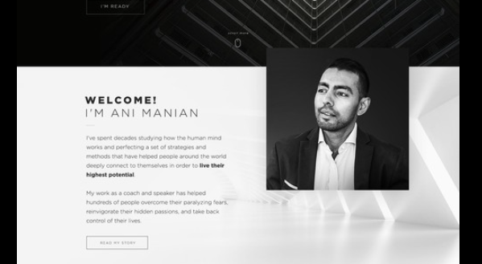  
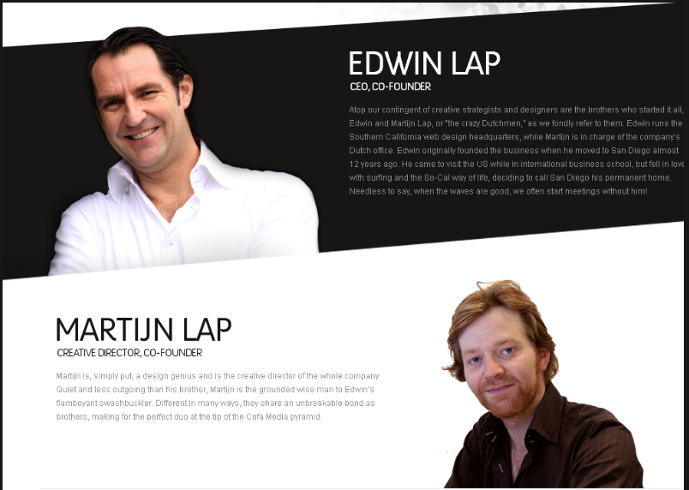

### Skills Snapshot

A visually engaging section highlighting key technical skills, such as programming languages, frameworks, tools, and systems. Icons or progress bars can visually represent your proficiency levels or areas of expertise.

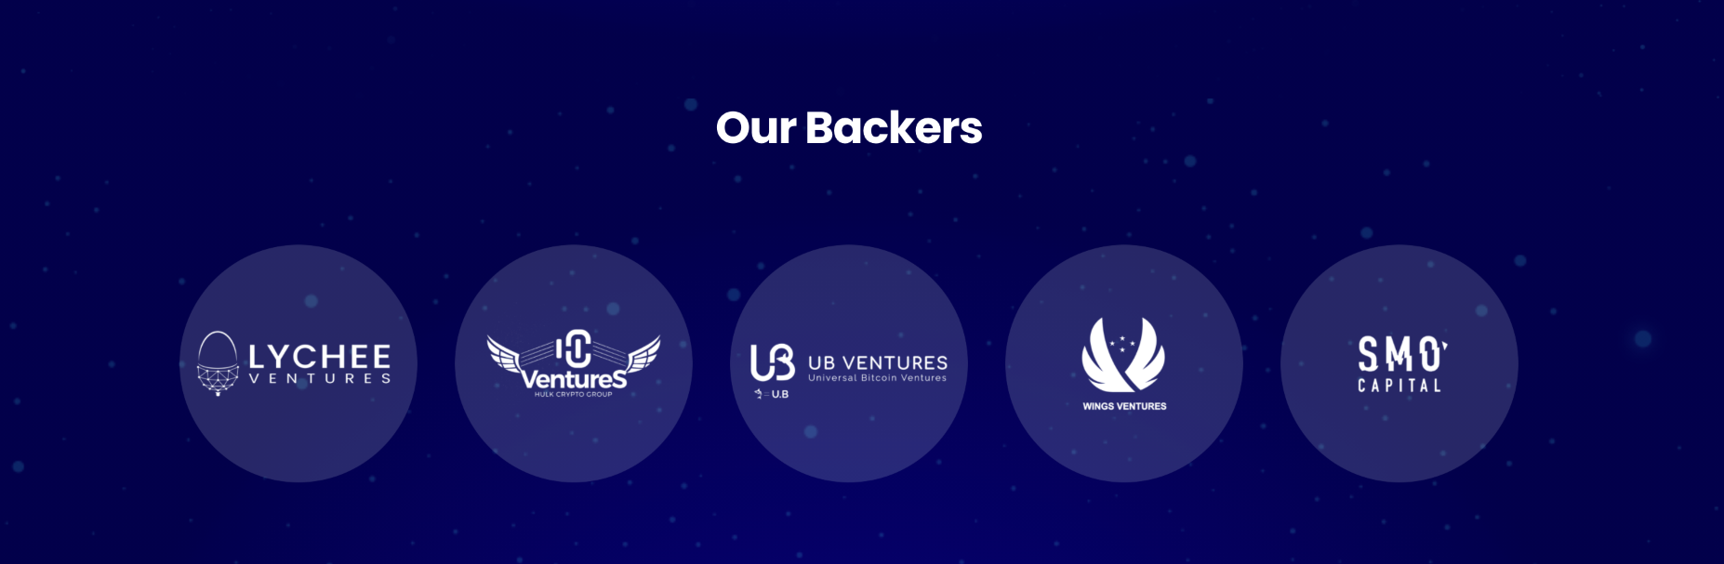

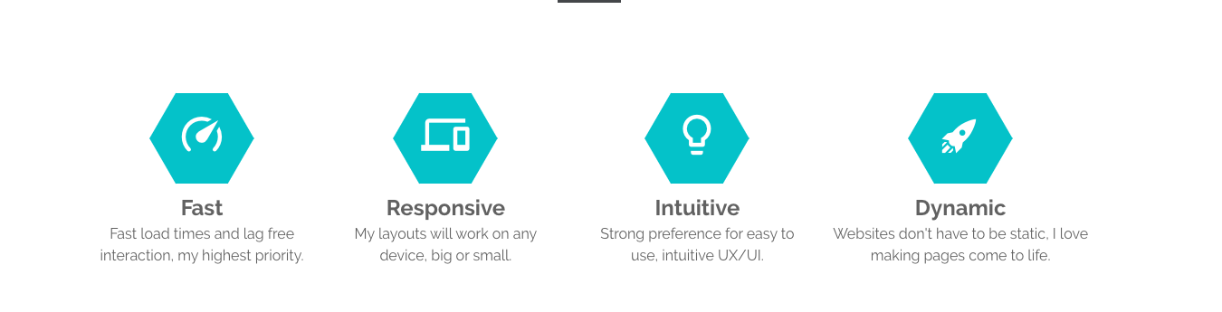

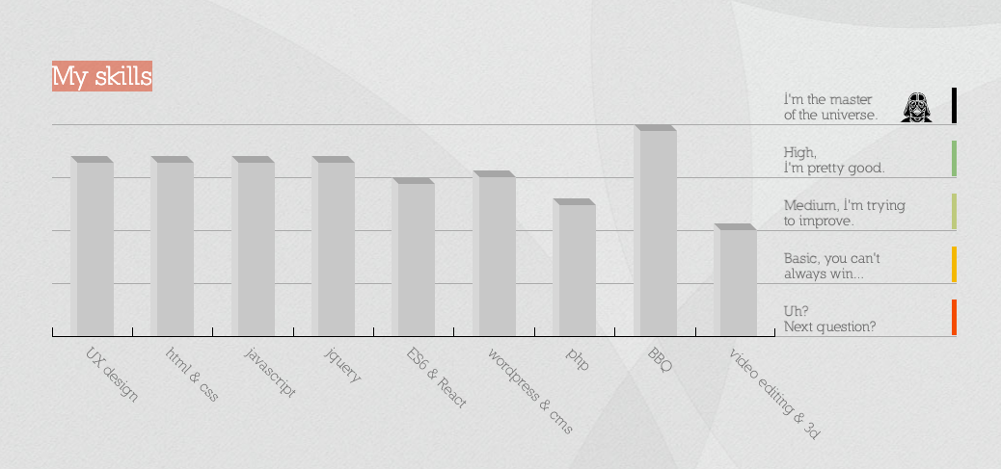

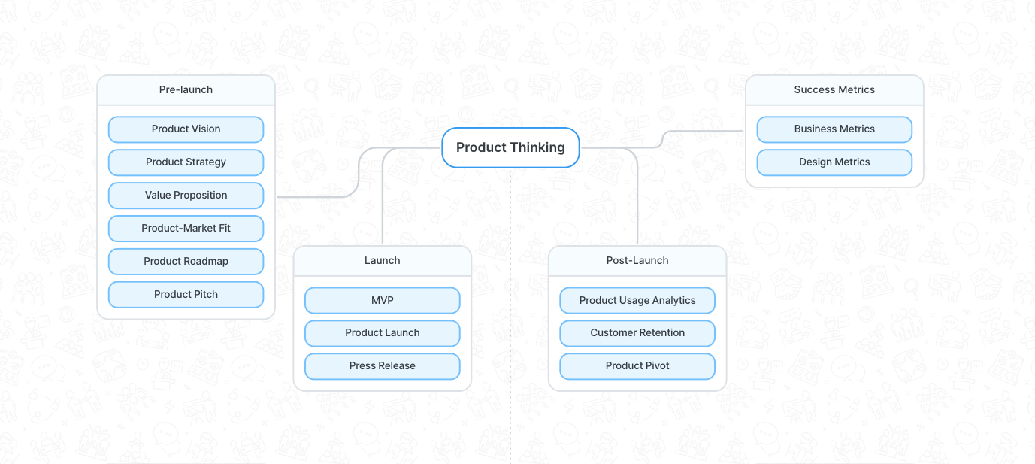

### Featured Projects / Blog Articles

Showcase a few select projects that best represent my work and achievements. Include a mix that covers different technologies and areas of interest. For each project, provide a brief description, the technology stack used, and outcomes. Links to case studies or GitHub repositories are highly beneficial. A snippet from your latest articles or blog posts can demonstrate your expertise and engagement with the software engineering community.

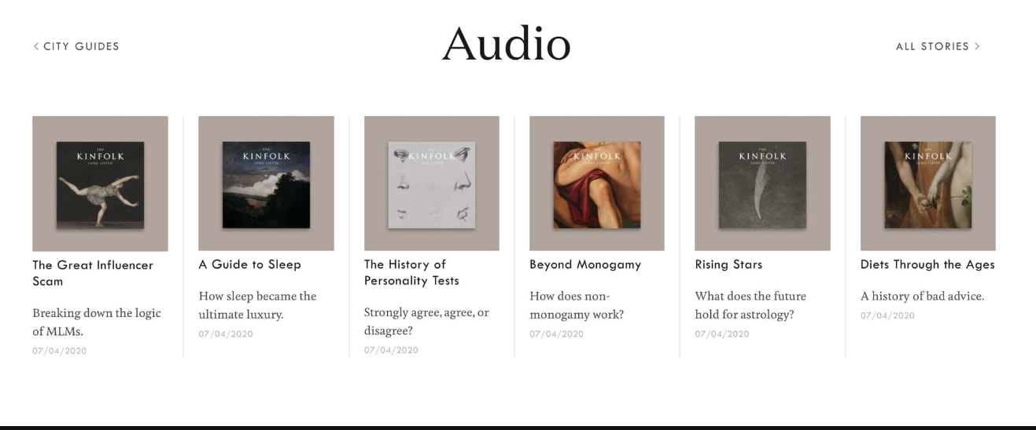

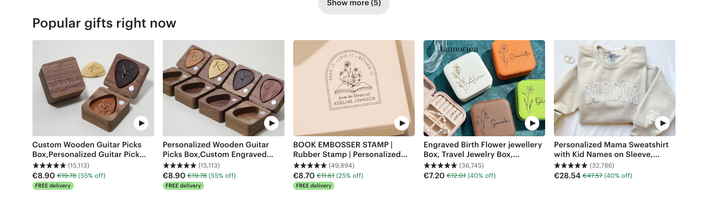

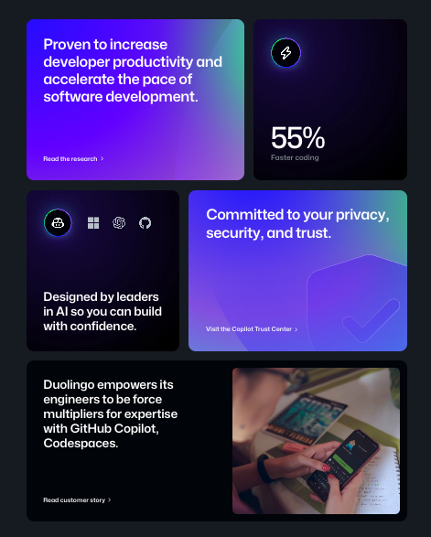

### Experience Overview

A brief section summarizing your professional experience, emphasizing roles or projects that showcase your skills and contributions. You might list your current or most impactful role here, inviting visitors to explore your detailed resume or LinkedIn profile for more information.

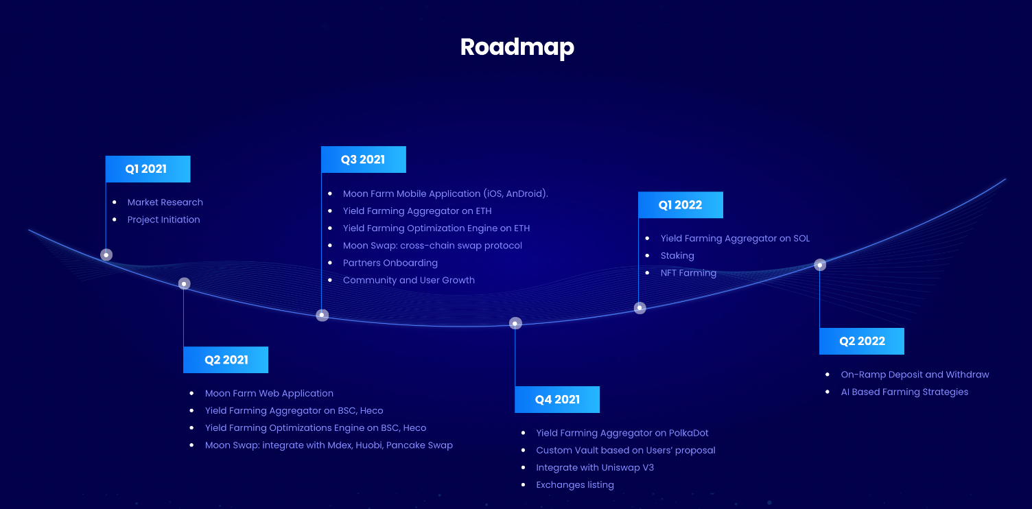

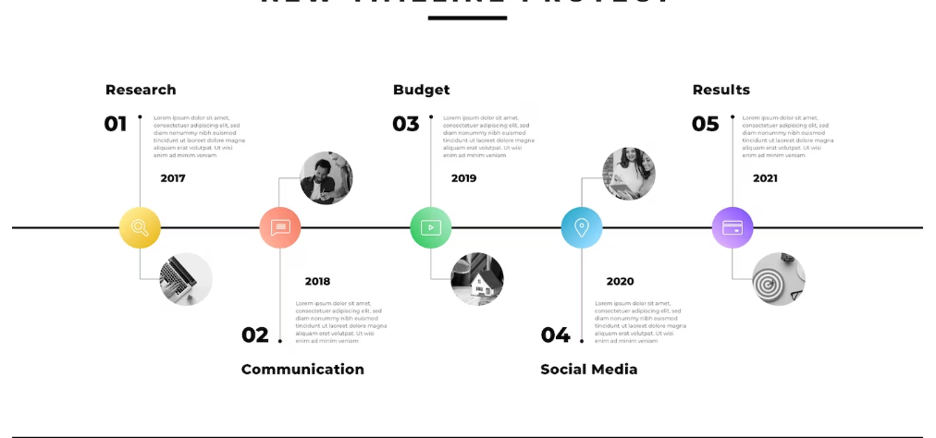

## Portfolio/Blog List

* Clicking on Blog or portfolio will bring user to the same page with relevant filter applied. Blog posts or projects, *“/posts?type=projects”, “/posts?type=article”*
* Overview of Michael's projects and skills
* Filterable portfolio gallery (Web Development, C++, Hardware Projects, etc.)
* Articles, tutorials (e.g., home server setup)
* Subscription option

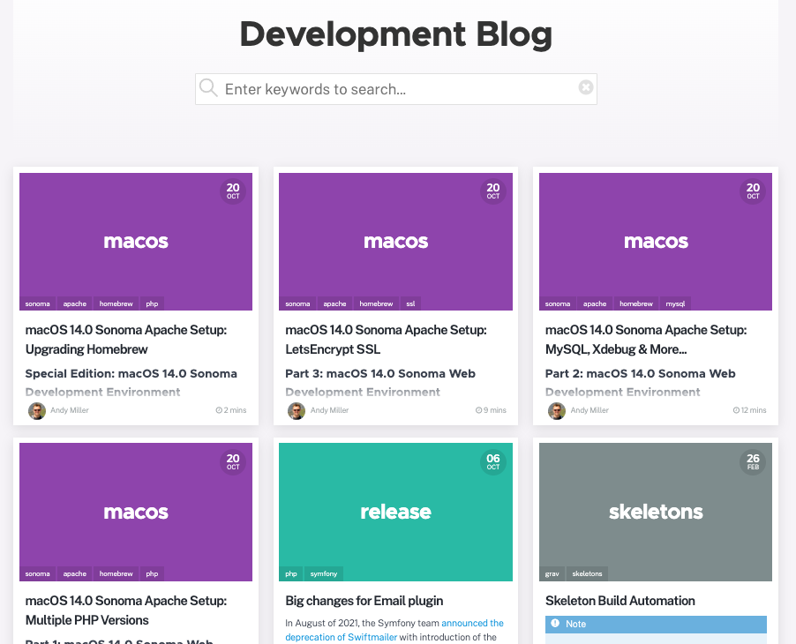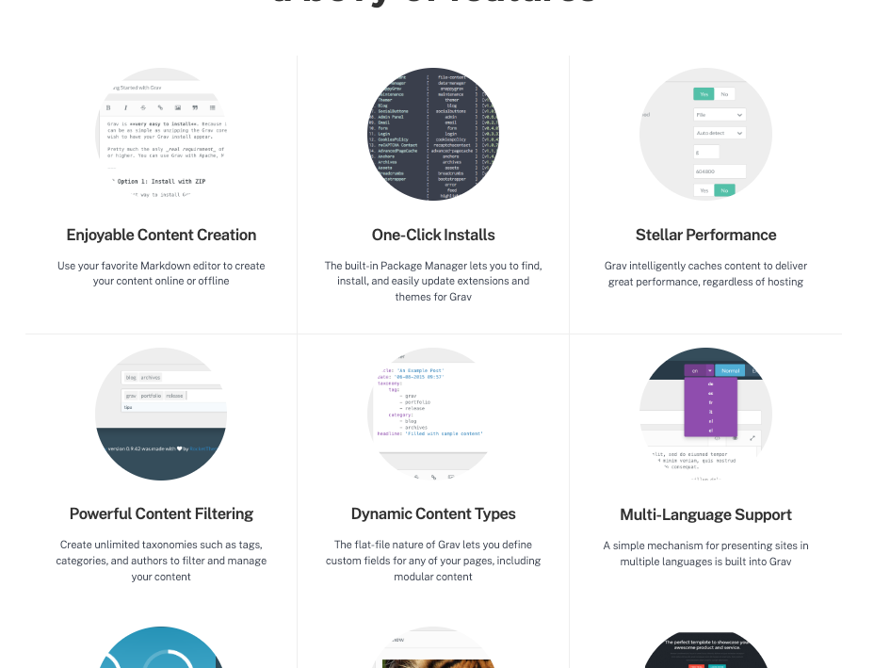

## Blog/Article Page

* Individual project details upon selection
* Estimated Read time
* Related Articles
* Share option

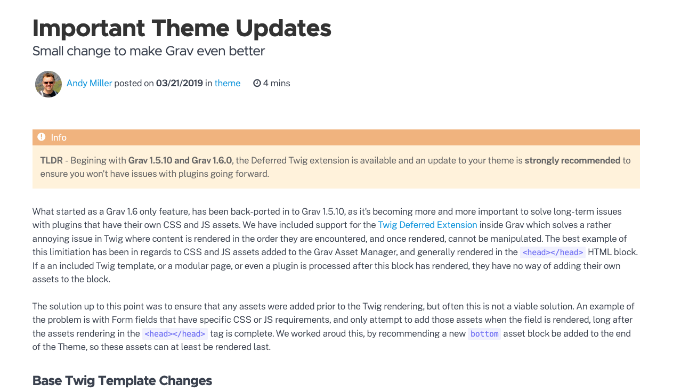

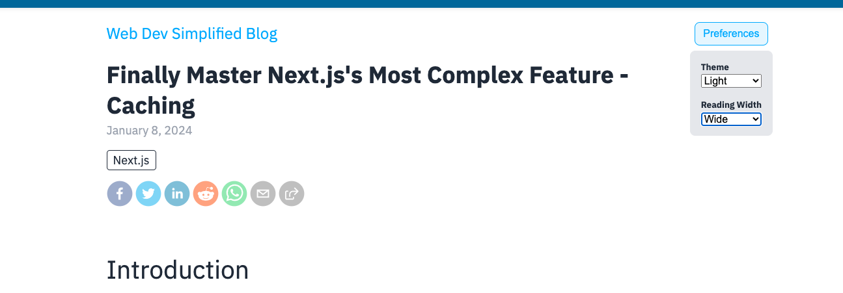

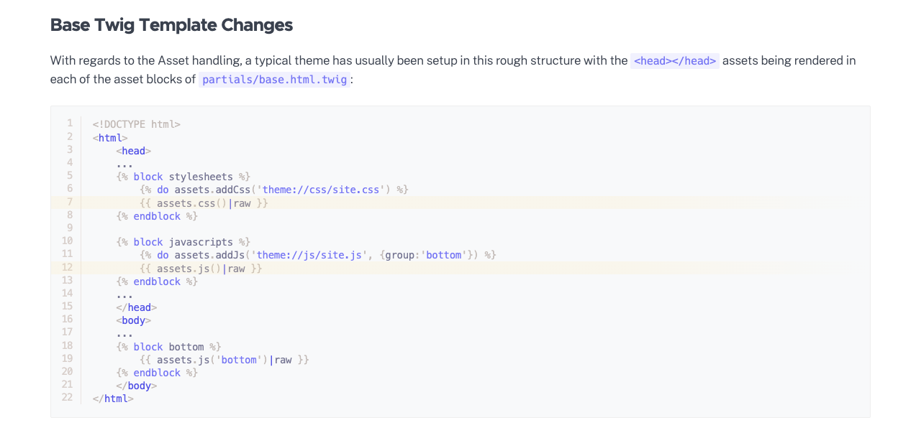

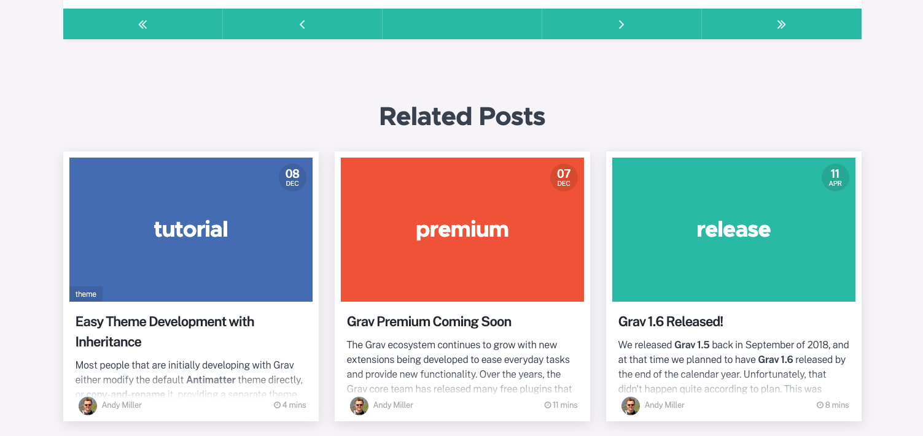

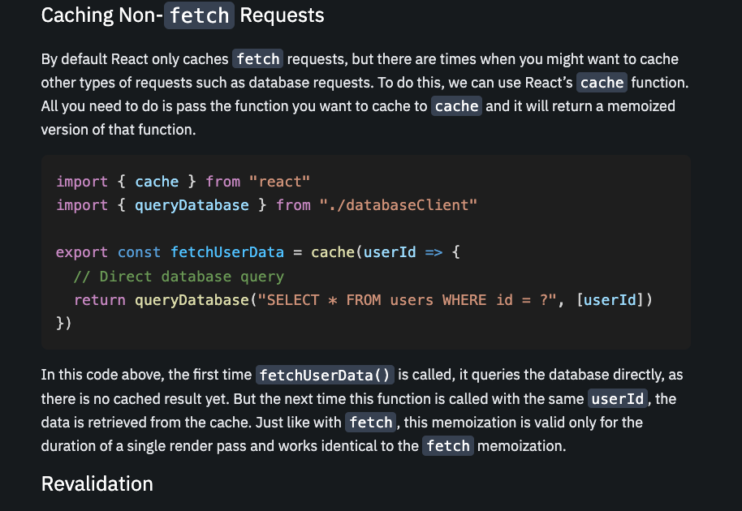

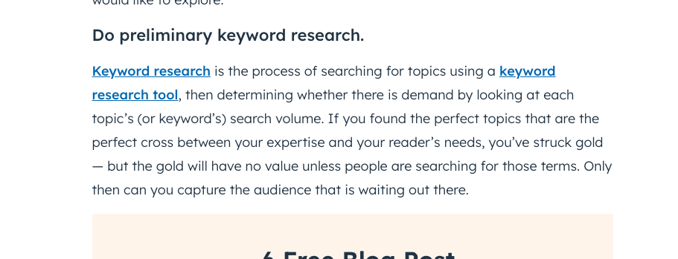

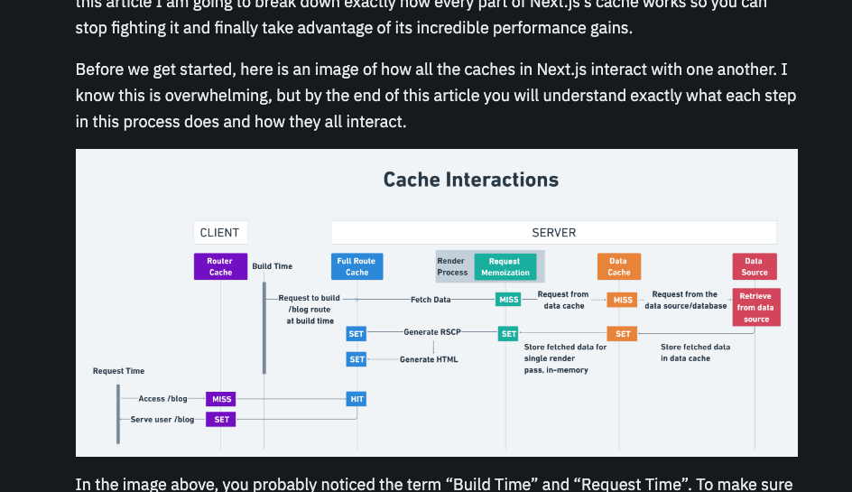

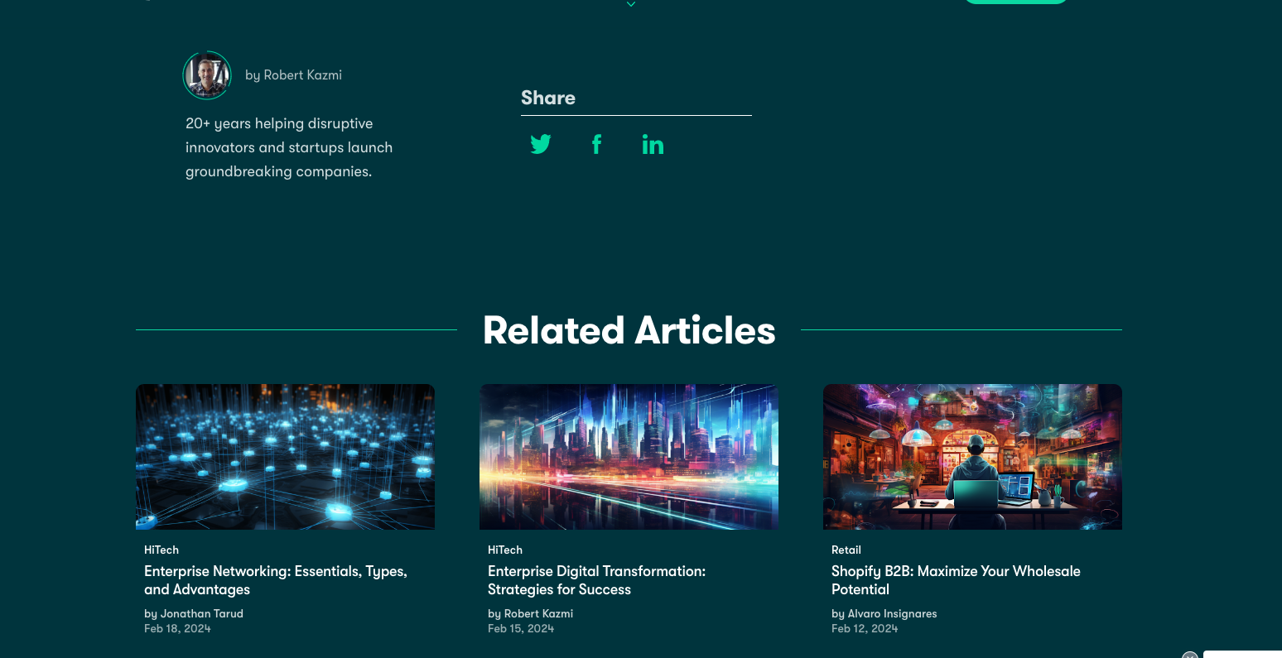

## About Page

* Professional bio and background
* More about my personality and hobbies, as the professional stuff is already on the site, if someone comes here, they are trying to find out a bit more about me.
* Skills and expertise showcase
* Contact button
* Links to other places

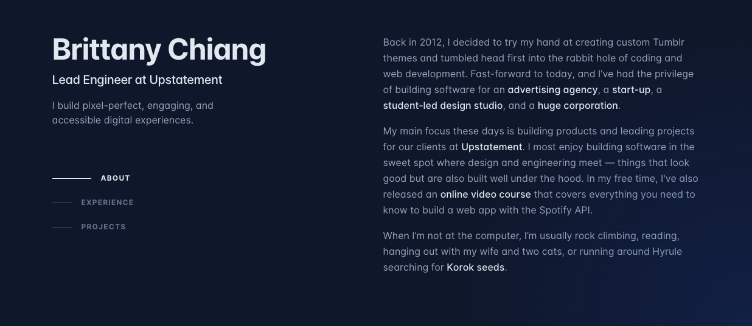

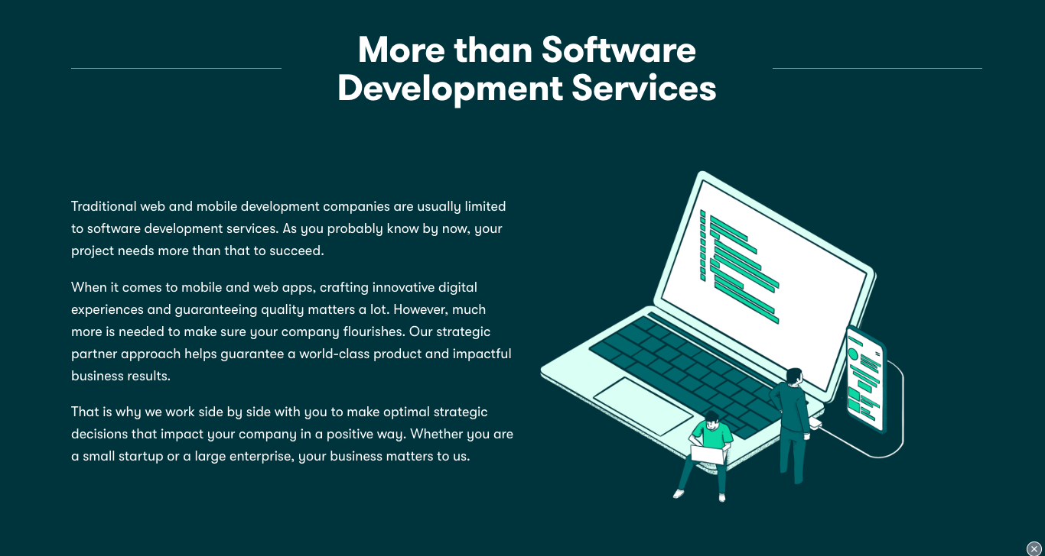

# Sub domain: dj.michaelgrinnell.com

## DJ Home Page

* Introduction to DJ persona
* Overview of DJ services and navigation to mixes, produced songs, and booking

## Mixes and Songs

* Gallery of DJ mixes and produced tracks
* Options to listen, download, or share

## DJ Services

* Types of events catered to
* Booking information

## DJ Contact Page

* Booking inquiry form
* Links to DJ focused social media and music platforms

# Implementation Plan

This is a high-level overview of the plan for designing, developing, testing and maintaining this website.

## Project Management

* Develop a comprehensive design document detailing objectives, strategies, and style guides.
* Set up a project management board using Trello to organize tasks, sprints, and deadlines.

## Frontend Development

* Create interactive UI elements such as buttons, navigation bars, and modals.
* Design templates and reusable components with placeholder content.
* Implement additional features such as animations, theme detection/switching
* Implement filters for project and blog post searching based on tags, categories, and dates.
* Code dynamic navigation logic for scrolling on the homepage and page navigation.

## Backend Development

* Set up a WordPress instance to serve as a headless CMS
* Use Postman to create and test API endpoints for frontend-backend communication.
* Ensure API endpoints are secure and efficiently handle data.
* Integrate WordPress REST API for content management and delivery.

## Content Integration

* Produce quality content for both sites, focusing on technical and DJ-related topics.
* Ensure content is SEO-optimized and accessible.

## Testing and Optimization

* Conduct cross-browser and cross-device testing to ensure compatibility and responsiveness.
* Perform performance optimization for load times and image optimization.
* Validate all animations and dynamic features function as intended.

## Deployment

* Point domain to the correct server addresses.
* Configure and finalize the home server for web hosting.
* Perform deployment testing to ensure live environments are fully operational.

## Maintenance:

* Regularly update content through WordPress to keep the sites current.
* Maintain up-to-date tools and frameworks to leverage new features and security patches.
* Set up a GitHub repository to streamline deployment processes and version control.

## Security and Analytics:

* Implement any necessary security measures, including regular checks and updates.
* Integrate analytics for continuous monitoring of user behaviour and site performance.

# Additional Notes

This project was created as a portfolio etc... but I also wanted it to serve as a template for future projects, so would have to build components in a reusable and modular ways.